
A 10
Sreenidhi Institute of Science & Technology
(An Autonomous Institution)
Code No: 101EE01/111EE01

B. TECH. I – Year II – Semester Examinations, June/July, 2012 (Regular/Suppli.)
CIRCUITS & NETWORKS - I ( EEE )

Time: 3 Hours Max. Marks : 70

Note : No additional answer sheets will be provided.

Part-A (Objective Type)
Max.Marks:20
Answer all QUESTIONS.
1. Define KVL and KCL.

2. Define i) tree ii) twigs

3. Find the total impedance of the circuit shown below.
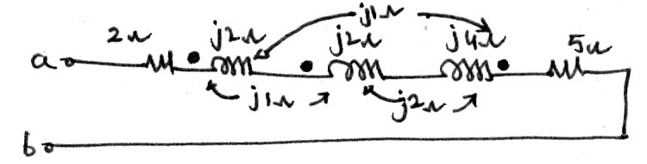
4. Write in brief about dot convention of coupling circuit.

5. What are half power frequencies?

6. Define MMF & Reluctance of magnetic circuit.

7. Define form factor and power factor.

8. Find V_{AB} for the below circuit.
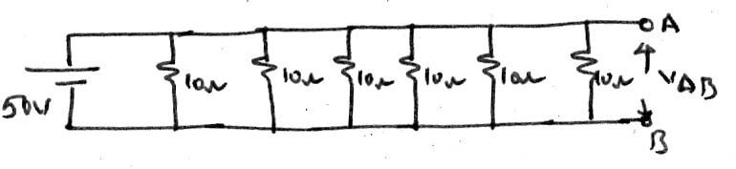
9. Define active and reactive powers.

10. State maximum power transfer theorem.

Part – B
Max. Marks: 50

ANSWER ANY FIVE QUESTIONS. EACH QUESTION CARRIES 10 MARKS.

1. Determine the node voltages V₁,V₂ and V₃ for the below circuit.
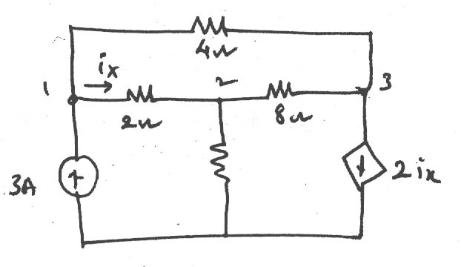
2 A
2. Transform the given current source into voltage source and then obtain the Loop currents in the below network.
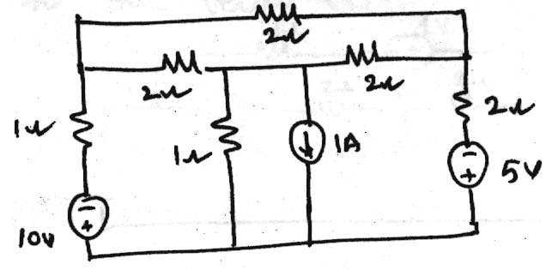
3. Write a set of mesh equations and then find mesh currents in the network shown below.
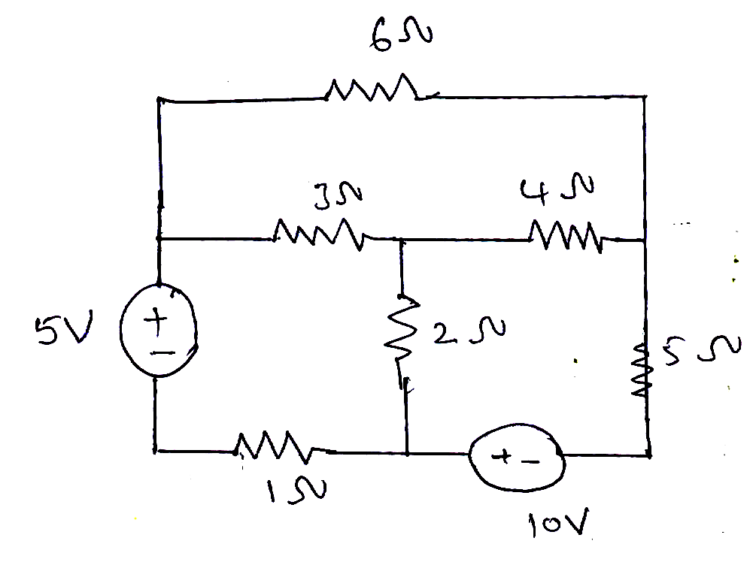
4. Find Tieset and cutset matrix for the given graph.
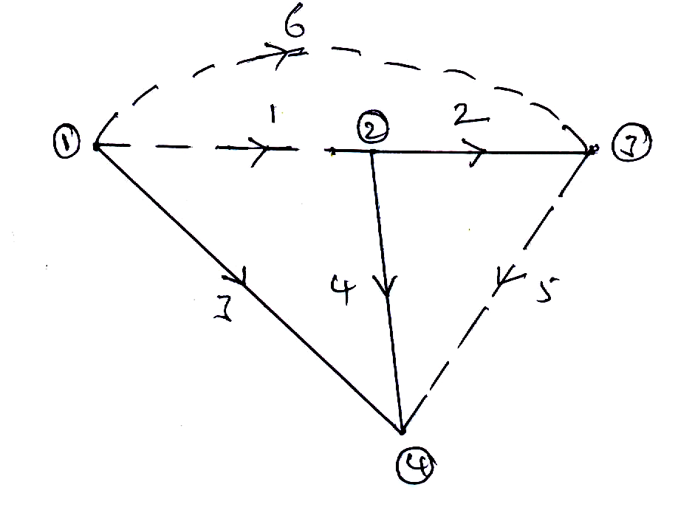
5. In the below circuit diagram R=2Ω, L=1mH and c=0.4μF.
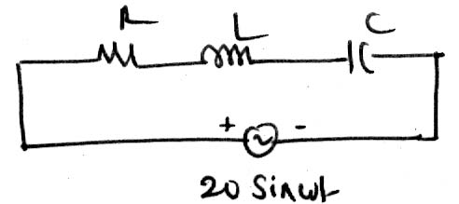
a) Find resonant frequency b) calculate quality factor
c) Determine ω₀, ω₁ & ω₂.
6. a) State Superposition theorem.
b) Obtain Norton's equivalent at terminals 1-1' for the below circuit
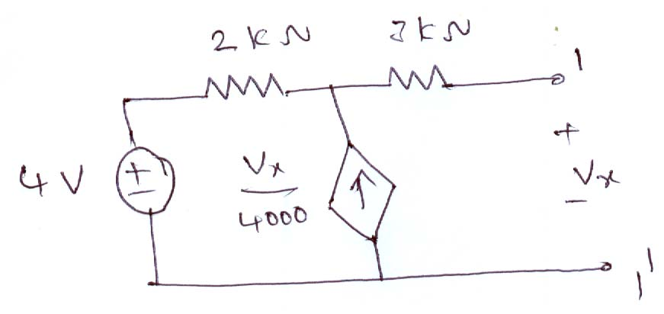
7. a) Define RMS and average values of a Sinusoidal wave.
b) Find the RMS, average values and form factor for the below wave.
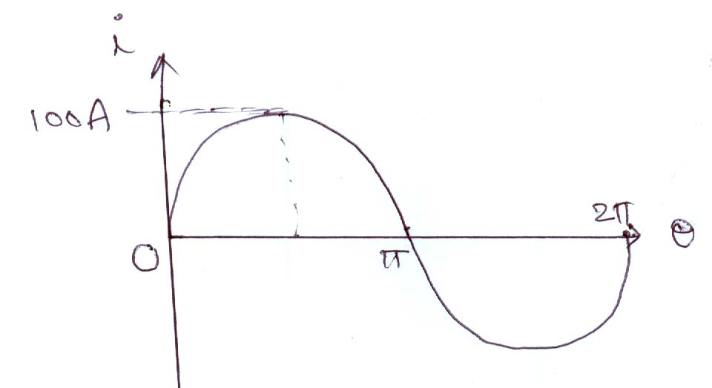

8. Write a short notes on the following
a) Duality and dual networks. b) Parallel resonance for R,L,C are in parallel.
-- 00 -- 00 --

